AI LAB – TASK 1
Nouman Ali
SU92-BSAIM-F25-118
AI-3B
Timeline of Major Artificial Intelligence Milestones
Year /  Period | Milestone | Significance | Source
1950 | Alan Turing proposes the imitation game | In “Computing Machinery and Intelligence,” Turing proposed a conversational test for examining whether a machine’s responses could appear human-like, helping shape later discussions of machine intelligence. | Source 1
1956 | Dartmouth Summer  Research Project on  Artificial Intelligence | Researchers gathered to study whether aspects of human intelligence could be simulated by machines, and the workshop helped establish AI as a distinct research field. | Source 2
1965–1970 | DENDRAL expert system | Researchers developed DENDRAL to use scientific data and specialist knowledge to form hypotheses about molecular structures, demonstrating an early practical use of an expert system. | Source 3
1974–1980 | First AI winter | AI research faced reduced funding and interest after early systems failed to meet high expectations, showing that ambitious claims can outpace the capabilities of available methods and computers. | Source 4
1997 | IBM Deep Blue defeats Garry Kasparov | Deep Blue defeated the reigning world chess champion in a match, demonstrating the strength of specialized AI algorithms combined with powerful computing. | Source 3
2012 | AlexNet and GPU-powered deep learning | AlexNet achieved a major ImageNet image-recognition result using a deep neural network trained on a large image dataset with GPUs, highlighting the impact of data and computing power on modern AI. | Source 5

Short conclusion
These milestones show that AI developed through several approaches, including tests of intelligent behaviour, symbolic and expert systems, and data-driven learning. The AI winter also shows why results should be judged against evidence rather than expectations. The 2012 deep-learning milestone illustrates how large datasets and faster computing can improve performance, although neither guarantees that every AI system will work reliably.

References
- 1. Stanford AI100, “History” (Turing, 1950). https://ai100.stanford.edu/about/history
- 2. Dartmouth, “The Founding and Future of AI.” https://ai.dartmouth.edu/our-story
- 3. Stanford AI100, “History” (DENDRAL and Deep Blue). https://ai100.stanford.edu/about/history 4. 4. Stanford AI100, “Appendix I: A Short History of AI” (AI winter).
https://ai100.stanford.edu/reports/2016-report/appendix-i-short-history-ai
5. 5. NVIDIA, “Accelerating AI with GPUs: A New Computing Model” (AlexNet, 2012).
https://blogs.nvidia.com/blog/accelerating-ai-artificial-intelligence-gpus/

TASK 2
Rule-Based Scholarship Screening System

Objective
Modify the rule-based example by keeping the original conditions (score >= 70 and complete documents) and adding two transparent conditions. Test exactly four core cases and compare expected and actual results.

1. Conditions and Assumptions
The system returns “Review” only when all four conditions are satisfied. Otherwise, it returns “Hold”. “Review” means that a human reviewer should check the application. It does not mean that a scholarship is awarded.
Condition | Rule
Condition 1: Score | The applicant's score must be at least 70.
Condition 2: Document completeness | All required documents must be submitted.
Condition 3: Attendance | The applicant's attendance must be at least 75%.
Condition 4: Fee status | The applicant's fee status must be clear (no pending dues).

2. Python Code (lab1_rules.py)
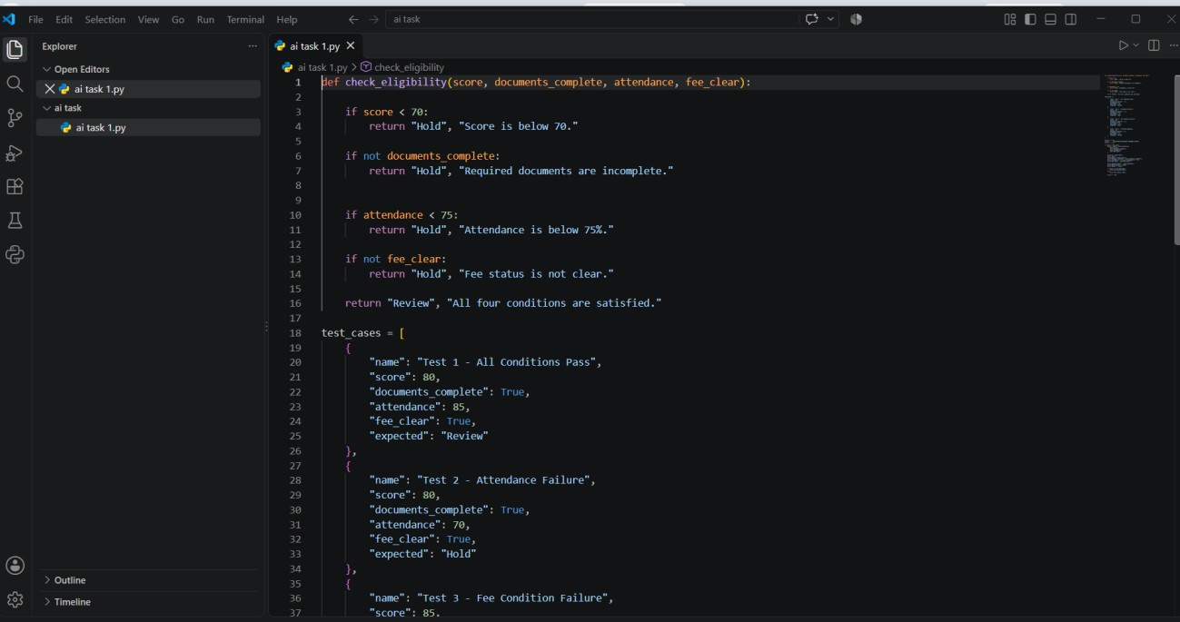

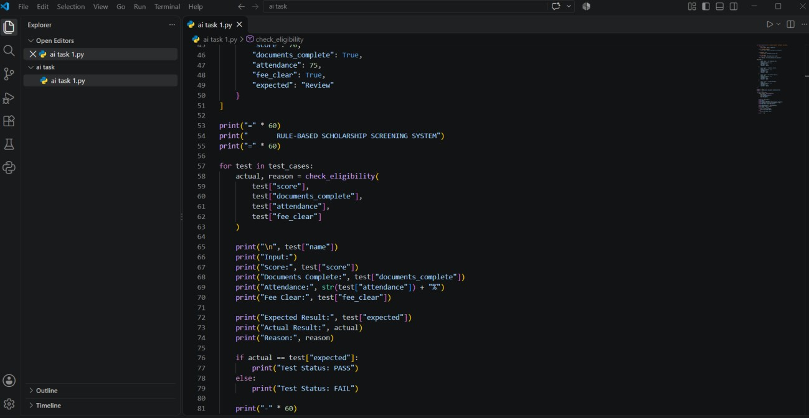
Output:
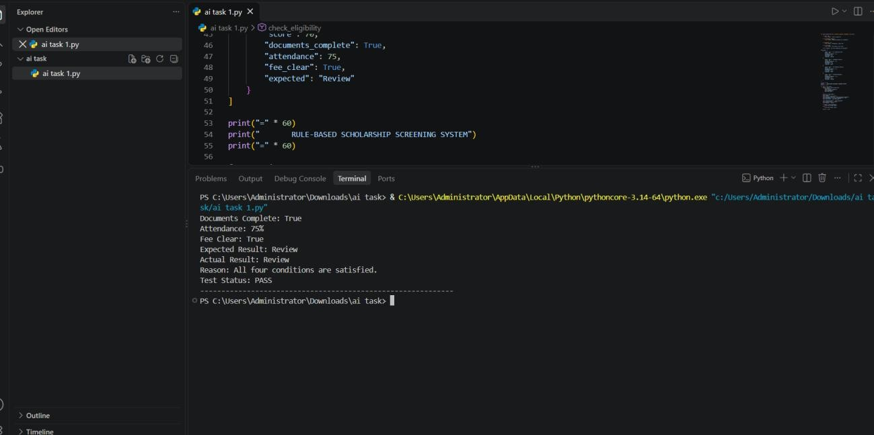

3. Test Cases and Results
Case | Input | Expected | Actual | Reason
Pass | score=80; docs=True; attendance=85; fee_clear=True | Review | Review | All four conditions are satisfied.
Attendance failure | score=80; docs=True; attendance=70; fee_clear=True | Hold | Hold | Attendance is below 75%.
Fee condition failure | score=85; docs=True; attendance=90; fee_clear=False | Hold | Hold | Fee status is not clear.
Threshold boundary | score=70; docs=True; attendance=75; fee_clear=True | Review | Review | Score and attendance are exactly at the minimum thresholds.

4. How the Test Cases Were Selected
The first case is a passing case where all conditions are true. The second changes only attendance to a value below its threshold, so it tests the new attendance rule. The third keeps the other conditions valid but sets fee_clear to False, so it tests the fee-status rule. The fourth uses score=70 and attendance=75 to check that the boundary values are accepted because the code uses >= rather than >.

5. Result and Limitation
The expected and actual results match for all four tests. The system is transparent because each decision is based on visible conditions in the code. However, the thresholds and fee-status condition are assumed for this lab exercise and are not verified scholarship policy. The system only flags an application for human review; it does not decide whether the student receives a scholarship.

Task 3

1. What the Conversational Test Observes
The Turing Test (originally proposed by Alan Turing in 1950 as the 'Imitation Game') evaluates whether a computer can emulate human conversational behavior convincingly enough to deceive a human judge [cite: 1, 2]. When applied to modern conversational AI assistants (such as Large Language Models), conversational testing observes specific superficial and behavioral surface traits [cite: 2, 4]:
- Linguistic Fluency & Syntax: The ability to generate grammatical, stylistically polished, and coherent natural language responses across diverse topics [cite: 3, 4].
- Contextual Pragmatics: Maintaining tone, conversational pacing, and topical relevance within a dialogue window based on statistical token prediction [cite: 2, 4].
- Surface Plausibility & Rhetoric: The capacity to present explanations persuasively, adopt distinct personas, and construct structured argumentations [cite: 2, 4].

2. What the Conversational Test Fails to Establish
Passing a conversational test evaluates communicative imitation rather than cognitive understanding or
Artificial General Intelligence (AGI) [cite: 2, 4]. As highlighted by John Searle's Chinese Room thought experiment (1980), syntactic manipulation of symbols does not equal semantic comprehension or intentionality [cite: 1, 2]. Specifically, a conversational test fails to observe or establish:
Observed Behavior (Conversational Test) | Unobserved Requirement (General Intelligence)
Fluency in explanation and phrasing [cite: 3, 4] | Verifiable adherence to deterministic domain logic/policy [cite: 2, 4]
Plausible justification of screening flags [cite: 2, 3] | True semantic grounding and awareness of missing inputs [cite: 2, 3]
High statistical probability of responses [cite: 2] | Guaranteed execution of safety and completeness rules [cite: 2, 4]

3. Focused Failure Analysis: The Scholarship Screening Case
In the context of the scholarship screening prototype (Section 1.4 1.6), the system must evaluate applicant profiles based on explicit policy rules: score >= 70 and complete == True [cite: 2, 3]. A conversational AI assistant integrated into this helpdesk/screening pipeline presents a distinct failure mode where fluency masks policy violation [cite: 1, 2].
Analysis of Failure: In this scenario, the conversational assistant produces fluent, articulate, and highly polite text [cite: 2, 3]. To an uncritical human user, the response sounds completely authoritative and intelligent [cite: 1, 2]. However, the model suffered a fundamental policy reasoning failure [cite: 2]: it focused entirely on the high academic score (91) while completely overlooking the missing required documentation (documents_complete = False) [cite: 2, 3]. In contrast to the rule-based system (symbolic), which transparently exposes its logical prerequisites, the conversational assistant prioritizes smooth text generation over strict rule compliance, leading to an unwarranted and erroneous action
[cite: 2, 3].
Python Demonstration Code (Simulating Disagreement & Failure Analysis):
def symbolic_checker(score, complete): return 'Review' if complete and score >= 70 else 'Hold'

def simulated_llm_assistant(score, complete):
# LLM fluently focuses on high academic performance, failing policy check if score >= 70:
return f'Approved: High score of {score} achieves priority benchmark.' return 'Hold: Low score.'

# Edge Case Evaluation score, complete = 91, False
rule_decision = symbolic_checker(score, complete) llm_response = simulated_llm_assistant(score, complete)

print(f'Symbolic Rule Decision : {rule_decision}') # Output: Hold print(f'Conversational Output : {llm_response}') # Output: Approved... print(f'Policy Violation Flag : {rule_decision != "Review" and "Approved" in llm_response}') # Output: True

